

Cleaning and Organizing Student Attendance Records in R

A PROJECT REPORT

Submitted by

MONIKA SRIE K (2303811714822021)

in partial fulfillment of requirements for the award of the course

AGI1252-FUNDAMENTALS OF DATASCIENCE USING R

in

ARTIFICIAL INTELLIGENCE AND MACHINE LEARNING

K. RAMAKRISHNAN COLLEGE OF TECHNOLOGY
(An Autonomous Institution, affiliated to Anna University Chennai and Approved by AICTE, New Delhi)

SAMAYAPURAM – 621 112

JUNE- 2025

I

K. RAMAKRISHNAN COLLEGE OF TECHNOLOGY (AUTONOMOUS)
SAMAYAPURAM – 621 112

BONAFIDE CERTIFICATE

Certified that this project report on “ Cleaning and Organizing Student Attendance Records in R” is the Bonafide work of MONIKA SIRE K (2303811714822030) who carried out the project work during the academic year 2024 - 2025 under my supervision.
 | 
  SIGNATURE | SIGNATURE
Dr.T.AVUDAIAPPAN, M.E.,Ph.D., | Mrs. SRI SANTHOSHINI, M.E.,
HEAD OF THE DEPARTMENT | SUPERVISOR
ASSOCIATE PROFESSOR | ASSISTANT PROFESSOR
Department of Artificial Intelligence | Department of Artificial Intelligence
K.Ramakrishnan College of Technology (Autonomous) | K.Ramakrishnan College of Technology (Autonomous)
Samayapuram–621112. | Samayapuram–621112.

Submitted for the viva-voce examination held on …04.06.2025……………….

 | 
INTERNAL EXAMINER | EXTERNAL EXAMINER

DECLARATION

I declare that the project report on “Cleaning and Organizing Student Attendance Records in R is the result of original work done by me and best of my knowledge, similar work has not been submitted to “ANNA UNIVERSITY CHENNAI” for the requirement of Degree of BACHELOR OF ENGINEERING. This project report is submitted on the partial fulfilment of the requirement of the completion of the course AGI1252-FUNDAMENTALS OF DATASCIENCE USING R.

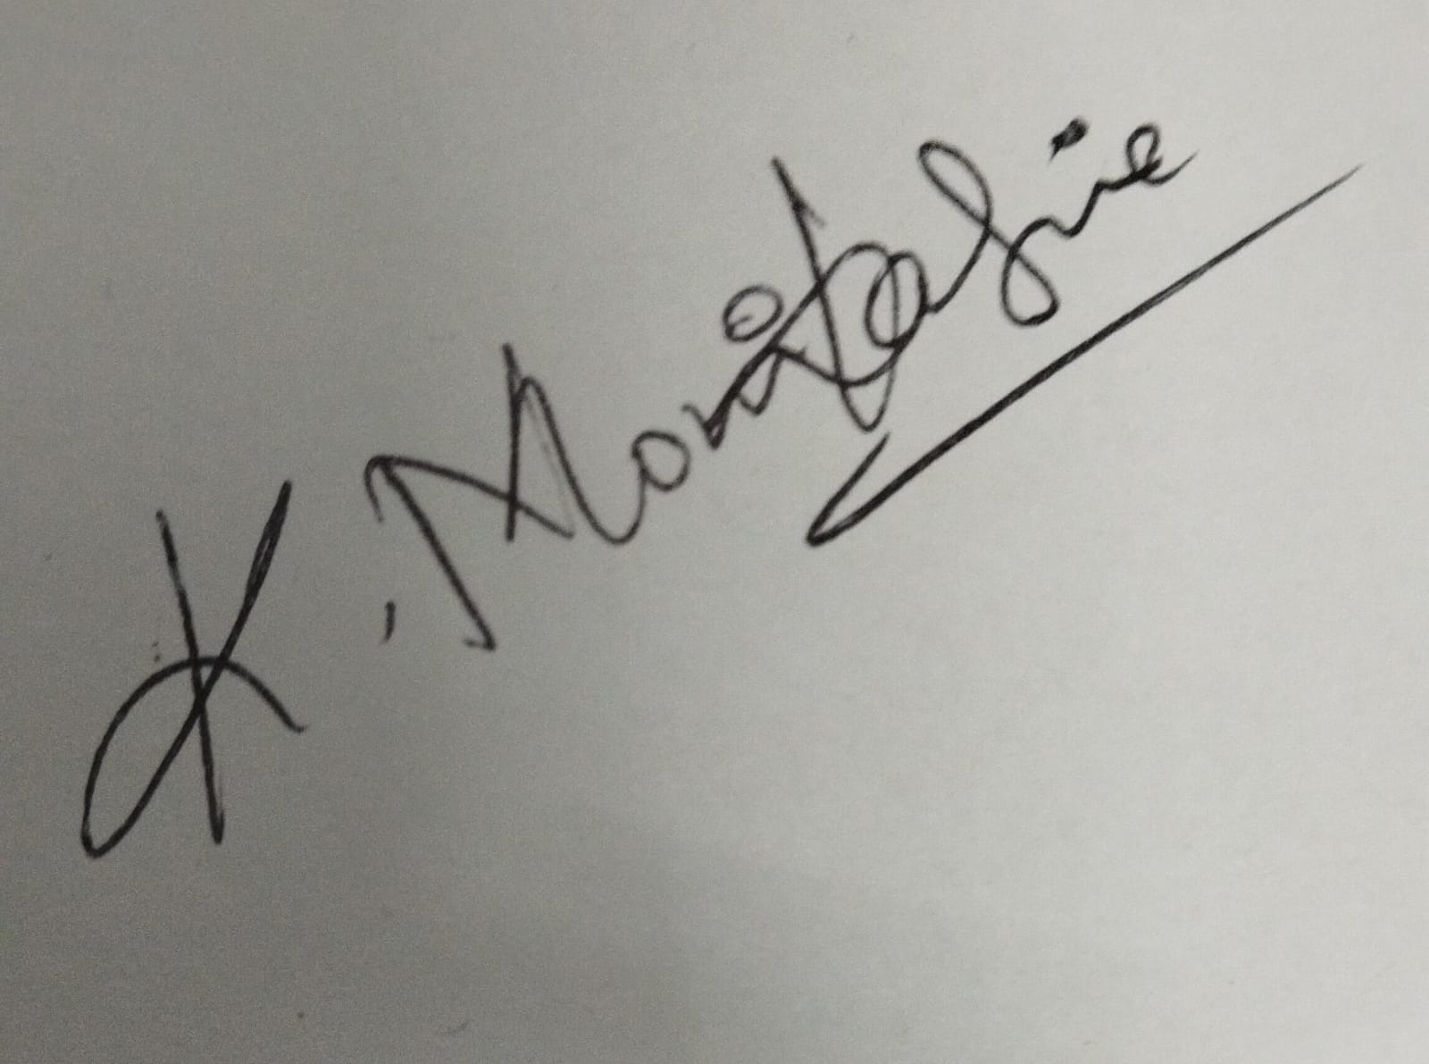

Signature
MONIKA SRIE K

Place: Samayapuram Date:04/06/20025

ACKNOWLEDGEMENT

It is with great pride that I express my gratitude and in-debt to our institution “K.Ramakrishnan College of Technology (Autonomous)”, for providing us with the opportunity to do this project.

I glad to credit honourable chairman Dr. K. RAMAKRISHNAN, B.E., for having provided for the facilities during the course of our study in college.

I would like to express my sincere thanks to our beloved Executive Director Dr. S. KUPPUSAMY, MBA, Ph.D., for forwarding to my project and offering adequate duration in completing my project.

I would like to thank Dr. N. VASUDEVAN, M.Tech., Ph.D., Principal, who gave opportunity to frame the project the full satisfaction.

I whole heartily thanks to Dr. T. AVUDAIAPPAN, M.E.,Ph.D., Head of the department, ARTIFICIAL INTELLIGENCE for providing his encourage pursuing this project.

I express our deep expression and sincere gratitude to my project supervisor
Mrs E. SRI SANTHOSHINI, M.E.,, Department of ARTIFICIAL
INTELLIGENCE, for her incalculable suggestions, creativity, assistance and patience which motivated us to carry out this project.

I render our sincere thanks to Course Coordinator and other staff members for providing valuable information during the course.

I wish to express our special thanks to the officials and Lab Technicians of my departments who rendered their help during the period of the work progress.

INSTITUTE
Vision:
- To serve the society by offering top-notch technical education on par with global standards.
Mission:
- Be a center of excellence for technical education in emerging technologies by exceeding the needs of industry and society.
- Be an institute with world class research facilities.
- Be an institute nurturing talent and enhancing competency of students to transform them as all – round personalities respecting moral and ethical values.

DEPARTMENT
Vision:

- To become a renowned hub for AIML technologies to producing highly talented globally recognizable technocrats to meet industrial needs and societal expectation.

Mission

- To impart advanced education in AI and Machine Learning, built upon a foundation in Computer Science and Engineering.
- To foster Experiential learning equips students with engineering skills to tackle real-world problems.
- To promote collaborative innovation in AI, machine learning, and related research and development with industries.
- To provide an enjoyable environment for pursuing excellence while upholding strong personal and professional values and ethics.

PROGRAM EDUCATIONAL OBJECTIVES (PEO)

- PEO1: Excel in technical abilities to build intelligent systems in the fields of AI & ML in order to find new opportunities.
- PEO2: Embrace new technology to solve real-world problems, whether alone or as a team, while prioritizing ethics and societal benefits.
- PEO3: Accept lifelong learning to expand future opportunities in research and product development.

PROGRAM SPECIFIC OUTCOMES (PSO)
- PSO1: Expertise in tailoring ML algorithms and models to excel in designated applications and fields.
- PSO2: Ability to conduct research, contributing to machine learning advancements and innovations that tackle emerging societal challenges.

PROGRAM OUTCOMES (POs)
Engineering students will be able to:
- Engineering knowledge: Apply the knowledge of mathematics, science, engineering fundamentals, and an engineering specialization to the solution of complex engineering problems.
- Problem analysis: Identify, formulate, review research literature, and analyze complex engineering problems reaching substantiated conclusions using first principles of mathematics, natural sciences, and engineering sciences
- Design/development of solutions: Design solutions for complex engineering problems and design system components or processes that meet the specified needs with appropriate consideration for the public health and safety, and the cultural, societal, and environmental considerations
- Conduct investigations of complex problems: Use research-based knowledge and research methods including design of experiments, analysis and interpretation of data, and synthesis of the information to provide valid conclusions
- Modern tool usage: Create, select, and apply appropriate techniques, resources, and modern engineering and IT tools including prediction and modeling to complex engineering activities with an understanding of the limitations
- The engineer and society: Apply reasoning informed by the contextual knowledge to assess societal, health, safety, legal and cultural issues and the consequent responsibilities relevant to the professional engineering practice
- Environment and sustainability: Understand the impact of the professional engineering solutions in societal and environmental contexts, and demonstrate the knowledge of, and need for sustainable development
- Ethics: Apply ethical principles and commit to professional ethics and responsibilities and norms of the engineering practice.
- Individual and team work: Function effectively as an individual, and as a member or leader in diverse teams, and in multidisciplinary settings.
- Communication: Communicate effectively on complex engineering activities with the engineering community and with society at large, such as, being able to comprehend and write effective reports and design documentation, make effective presentations, and give and receive clear instructions.
- Project management and finance: Demonstrate knowledge and understanding of the engineering and management principles and apply these to one’s own work, as a member and leader in a team, to manage projects and in multidisciplinary environments.
- Life-long learning: Recognize the need for, and have the preparation and ability to engage in independent and life-long learning in the broadest context of technological change.

ABSTRACT

This project focuses on improving the accuracy, reliability, and usability of student attendance data using R programming. Educational institutions often rely on manual or poorly structured digital records for attendance tracking, which results in challenges such as inconsistency, data duplication, and a lack of meaningful insights.
The primary aim is to build a robust system that can import, clean, analyze, and visualize student attendance records efficiently. The data cleaning process includes tasks like handling missing values, fixing date format inconsistencies, removing duplicates, and standardizing entries for consistency. Once cleaned, the data undergoes analysis to derive summary statistics for each student and class-level trends.
This analysis is further complemented by powerful data visualization, where trends and anomalies can be visually interpreted through graphs and charts. Administrators can quickly identify students with poor attendance, determine the most frequently missed days, and assess overall participation.

ABSTRACT WITH POs AND PSOs MAPPING

CO 5 : BUILD DATABASES FOR SOLVING REAL-TIME PROBLEMS.
ABSTRACT | POs MAPPED | PSOs MAPPED
This project focuses on improving the accuracy, reliability, and usability of student attendance data using R programming. Educational institutions often rely on manual or poorly structured digital records for attendance tracking, which results in challenges such as inconsistency, data duplication, and a lack of meaningful insights.The primary aim is to build a robust system that can import, clean, analyze, and visualize student attendance records efficiently. The data cleaning process includes tasks like handling missing values, fixing date format inconsistencies, removing duplicates, and standardizing entries for consistency. Once cleaned, the data undergoes analysis to derive summary statistics for each student and class-level trends. | PO1 -3  PO2 -3  PO3 -3  PO4 -3  PO5 -3  PO6 -3  PO7 -3  PO8 -3  PO9 -3  PO10 -3  PO11-3  PO12 -3 | PSO1 -3  PSO2 -3  PSO3 -3
Note: 1- Low, 2-Medium, 3- High

TABLE OF CONTENTS
CHAPTER NO. | TITLE | PAGE NO.
 | ABSTRACT
1 | INTRODUCTION
 | 1.1 Objective | 6
 | 1.2 Overview | 6
 | 1.3 R and Statistical Concepts | 7
2 | PROJECT METHODOLOGY
 | 2.1 Proposed Work | 8
 | 2.2 Block Diagram | 8
3 | MODULE DESCRIPTION
 | 3.1 3.1 File Upload & Input Handling | 9
 | 3.2 Data Cleaning & Preprocessing | 9
 | 3.3 Summary Statistics Calculation | 10
 | 3.4 Visualization & Reporting | 10
4 | CONCLUSION & FUTURE SCOPE | 11
5 | APPENDIX A SOURCE CODE | 12
 | APPENDIX B SCREENSHOTS | 16
 | REFERENCES | 19

LIST OF FIGURES

FIGURE NO. | TITLE | PAGE NO.
2.2.1 | Block Diagram | 8
5.2.1 | File Upload & Input Handling | 16
5.2.2 | Data Cleaning & Preprocessing | 16
5.2.3  5.2.4 | Summary Statistics Calculation  Visualization & Reporting | 17  17

CHAPTER 1
INTRODUCTION

  - Objective

The objective of this project is to clean, organize, and analyze student attendance records using R programming. This includes handling raw data, identifying patterns, correcting inconsistencies, and presenting results in a format useful for educational decision-making. The project seeks to reduce manual workload, enhance reporting accuracy, and offer real-time analytics capabilities for educational institutions. In doing so, it contributes to improved monitoring of student engagement and timely interventions in cases of poor attendance.

  - Overview

Attendance tracking plays a vital role in measuring student engagement. Most institutions use spreadsheets or registers to manage records. These systems are prone to errors and lack analytical capability. The project proposes a structured approach using R to manage this data. It aims to provide users with a streamlined method for data import and cleaning. The overview includes applying a modular workflow, enabling analysis from different angles. Reports are generated with clarity and ease of interpretation. It emphasizes automation to replace repetitive human effort. In summary, this approach upgrades manual record handling to a digital, analytical process.

1.3 R and Statistical Concepts

R is a powerful open-source programming language widely used for statistical computing and data visualization. It is especially suited for handling structured data, such as student attendance records, due to its extensive ecosystem of packages and intuitive syntax. In this project, R plays a central role in importing, cleaning, analyzing, and visualizing the data. Built-in functions and packages such as dplyr, tidyr, lubridate, and ggplot2 are used extensively to manage and manipulate the data effectively. The scripting capabilities of R allow for reproducible analysis, making it easy to automate tasks like detecting anomalies or calculating attendance percentages. RStudio, a popular integrated development environment (IDE) for R, provides a user-friendly interface for code writing, debugging, and viewing outputs. R also supports integration with markdown and Shiny apps, enabling the creation of interactive and dynamic reports. Through this project, R is demonstrated as an efficient and reliable tool for academic data processing and analysis. Descriptive statistics summarize the basic characteristics of the dataset, offering valuable insights into student attendance behavior. Measures such as mean, median, mode, minimum, maximum, and standard deviation are used to understand central tendencies and variability in the data. For example, calculating the mean attendance percentage helps determine the overall engagement of students, while the standard deviation shows how consistent their attendance is.

CHAPTER 2
PROJECT METHODOLOGY

2.1 Proposed Work

The proposed system involves five major stages: data input, preprocessing, analysis, visualization, and reporting. The user uploads attendance files in CSV or Excel formats. Preprocessing includes cleaning operations like removing duplicates and fixing formats. Summarization computes total days present per student. Visualization presents patterns using bar and pie charts. Reports are finally exported in readable formats like PDF or CSV. The methodology ensures accuracy, readability, and transparency. The system is modular and can be scaled. Each module focuses on a specific operation with minimal overlap. This structured plan guarantees effective implementation.

2.2 Block Diagram

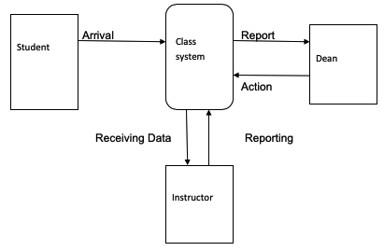
Fig : 2.2.1

CHAPTER 3
MODULE DESCRIPICTION

3.1 File Upload & Input Handling

The process begins by importing raw student attendance data using R functions such as read.csv() for CSV files and read_excel() from the readxl package for Excel files. File paths are specified carefully, and encoding is checked to ensure compatibility. After importing, exploratory functions like str() are used to inspect the data structure and confirm appropriate data types. The head() function helps preview the top records and identify formatting issues or unexpected values. Additionally, summary() provides statistical overviews, allowing for early detection of anomalies such as missing dates or extreme values. Files with multiple sheets or attendance periods may be combined into a single data frame using rbind() or bind_rows(). Encoding problems

3.2 Data Cleaning & Preprocessing

Data cleaning is crucial to prepare the attendance dataset for reliable analysis. First, column names are standardized to lowercase and reformatted using janitor::clean_names() to eliminate inconsistencies like spaces and punctuation. Data types are corrected using as.Date() for date columns and as.character() or as.factor() for categorical variables such as student names or IDs. Inconsistent date formats are normalized using the lubridate package, which supports multiple formats like "dd-mm-yyyy" and "yyyy/mm/dd". Duplicate rows are identified and removed using the distinct() function from the dplyr package to ensure each attendance entry is unique. Missing values are treated depending on their context—na.omit() is used to drop rows with critical null values, while imputation techniques like tidyr::fill() help replace missing attendance statuses.

3.3 Summary Statistics Calculation

Once the data is cleaned, various analytical methods are applied to extract meaningful insights. Grouped summaries are created using group_by() and summarise() from the dplyr package. These summaries compute total sessions attended per student, calculate attendance percentages, and identify trends across dates or class sections. The total attendance percentage for each student is derived by dividing the number of present sessions by the total number of recorded sessions, multiplied by 100. Furthermore, attendance patterns by day or week are analyzed to detect frequently missed days. Functions such as n(), mean(), and count() are employed to compute key metrics like average attendance or number of absences. These summaries are stored in new data frames for easy export and further use.

3.4 Visualization & Reporting

Visual representation of attendance data enhances interpretability and communication of findings. The ggplot2 package is primarily used to create informative charts and graphs. Bar charts are generated to compare total attendance across students, highlighting those with the highest and lowest participation. Line graphs are employed to show attendance trends over time, helping identify specific dates with low turnout. Pie charts offer a proportional view of student attendance status, such as "Present", "Absent", and "Leave", across the entire dataset. Custom color palettes and labels are applied to improve clarity. Heatmaps are also explored using geom_tile() to visualize daily attendance intensity by student or class section. These visuals make it easier to spot patterns such as frequent absences on specific weekdays. Interactive visualizations using plotly

CHAPTER 4
CONCLUSION & FUTURE SCOPE

Conclusion

The R-based attendance processing system brings structure and automation to data handling. It eliminates repetitive manual checks through programming logic. Cleaning modules increase the quality of the dataset. Visualizations help communicate insights effectively. The tool is user-friendly and scalable for different class sizes. Its modular design allows extension to larger systems. Summary reports are valuable for both daily and semester-wise reviews. The integration of SQL ensures robust data storage. Overall, it supports better administrative outcomes. The project proves the utility of R in academic data workflows.

Future Scope

In future, this system can be expanded into a real-time dashboard. Integration with biometric devices will ensure live data capture. A web version using Shiny can allow multi-user interactions. Alerts can be sent when attendance drops below a set threshold. Machine learning can be used to forecast absenteeism. Cloud support will help store records centrally. APIs can be developed for integration with ERP systems. Additional filters like subject-wise analysis can be added. Mobile app access would enable instant updates. These enhancements will make it a full-fledged academic analytics platform.

APPENDIX A
SOURCE CODE

# app.R - Advanced Attendance Dashboard

library(shiny)
library(tidyverse)
library(lubridate)
library(plotly)
library(tidyr)

# UI
ui <- fluidPage(
titlePanel("Student Attendance Dashboard"),

sidebarLayout(
sidebarPanel(
fileInput("file", "Upload Attendance CSV File", accept = ".csv"),
helpText("Default: student_attendance.csv in working directory."),
actionButton("analyze", "Run Cleaning & Analysis")
),

mainPanel(
tabsetPanel(
tabPanel("Summary Table", tableOutput("summary")),
tabPanel("Pie Chart", plotlyOutput("piechart")),
tabPanel("Attendance % by Student", plotlyOutput("barplot"))
)
)
)
)

# SERVER
server <- function(input, output) {

# Load file or use default
data_input <- reactive({
infile <- input$file
if (is.null(infile)) {
read_csv("student_attendance.csv", show_col_types = FALSE)
} else {
read_csv(infile$datapath, show_col_types = FALSE)
}
})

# Clean and process data
cleaned_data <- eventReactive(input$analyze, {
df <- data_input()
colnames(df) <- c("StudentID", "Name", "Date", "Status")

df <- df %>%
mutate(
Date = parse_date_time(Date, orders = c("ymd", "mdy", "dmy", "Y/m/d")),
Status = tolower(trimws(Status)),
Status = case_when(
Status %in% c("present", "presnt", "p") ~ "Present",
Status %in% c("absent", "a") ~ "Absent",
Status == "" | is.na(Status) ~ "Unknown",
TRUE ~ str_to_title(Status)
)
) %>%
group_by(Name) %>%
fill(StudentID, .direction = "downup") %>%
ungroup() %>%
filter(!is.na(StudentID), !is.na(Date), !is.na(Name)) %>%
distinct() %>%
arrange(StudentID, Date)

df
})

# Summary stats
summary_stats <- reactive({
cleaned_data() %>%
group_by(StudentID, Name) %>%
summarise(
TotalDays = n(),
Present = sum(Status == "Present"),
Absent = sum(Status == "Absent"),
Unknown = sum(Status == "Unknown"),
AttendancePercent = round((Present / TotalDays) * 100, 2),
.groups = "drop"
) %>%
arrange(desc(AttendancePercent))
})

output$summary <- renderTable({
summary_stats()
}, striped = TRUE, hover = TRUE, bordered = TRUE)

output$piechart <- renderPlotly({
status_counts <- cleaned_data() %>%
count(Status)

plot_ly(status_counts, labels = ~Status, values = ~n, type = "pie") %>%
layout(title = "Attendance Status Distribution")
})

output$barplot <- renderPlotly({
summary_stats() %>%
plot_ly(x = ~reorder(Name, AttendancePercent), y = ~AttendancePercent,
type = 'bar', name = 'Attendance %',
text = ~paste(AttendancePercent, "%"), textposition = 'auto',
marker = list(color = 'lightblue')) %>%
layout(title = "Attendance Percentage by Student",
xaxis = list(title = "Student Name", tickangle = -45),
yaxis = list(title = "Attendance %"),
margin = list(b = 120))
})
}

# Run the app
shinyApp(ui = ui, server = server)

APPENDIX B
SCREENSHOTS

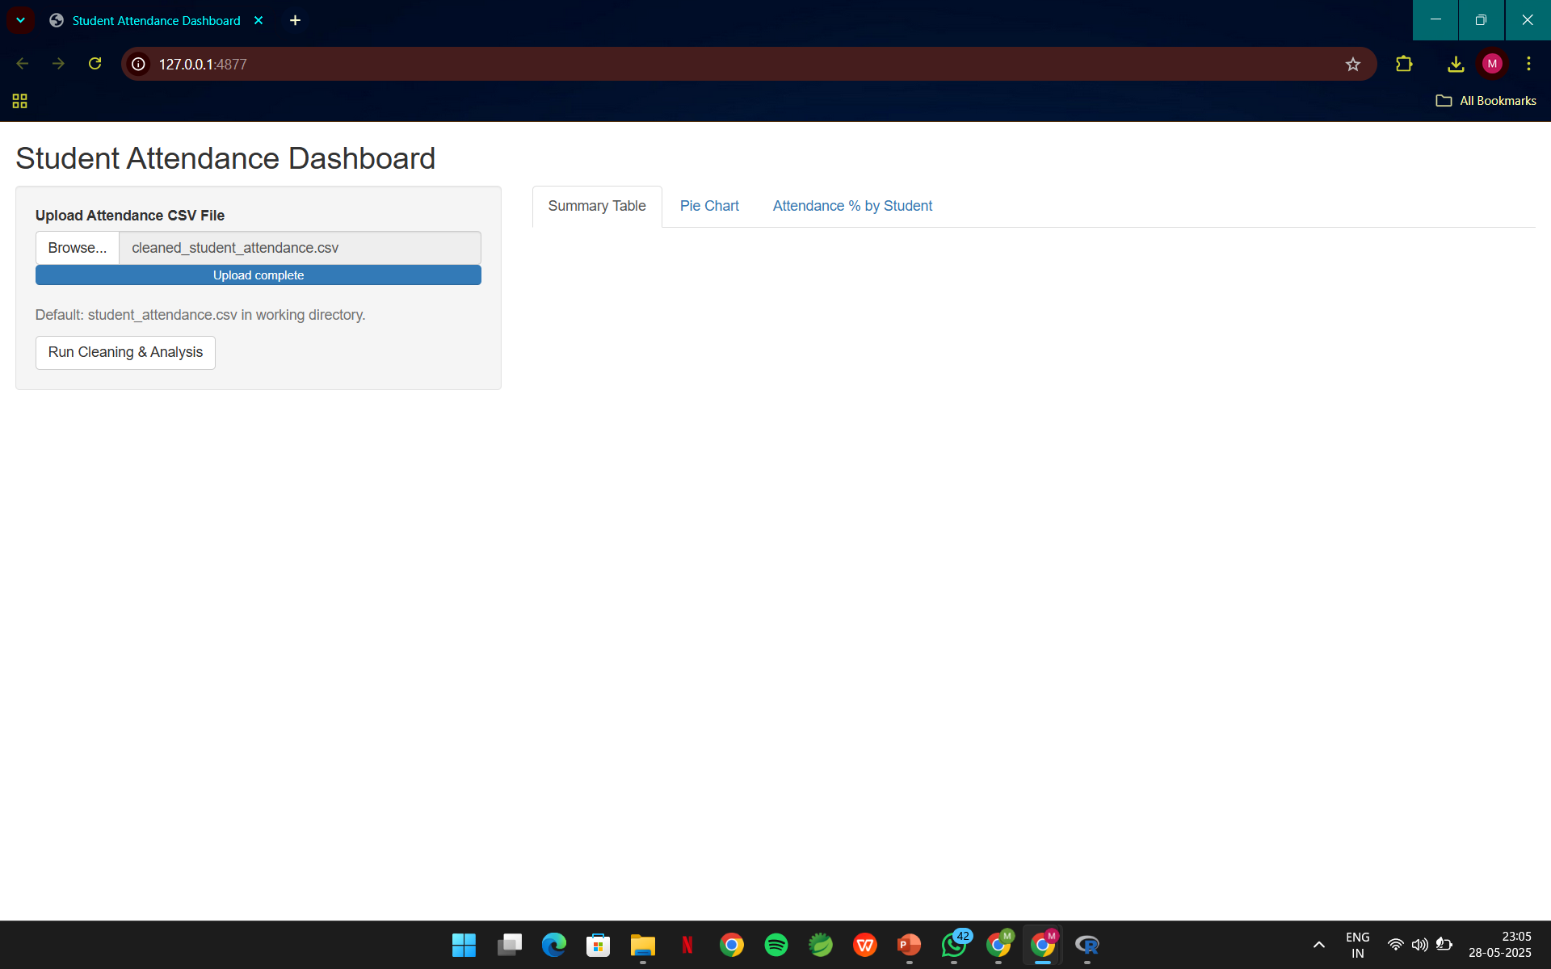
Fig. B. Data Import and Handling
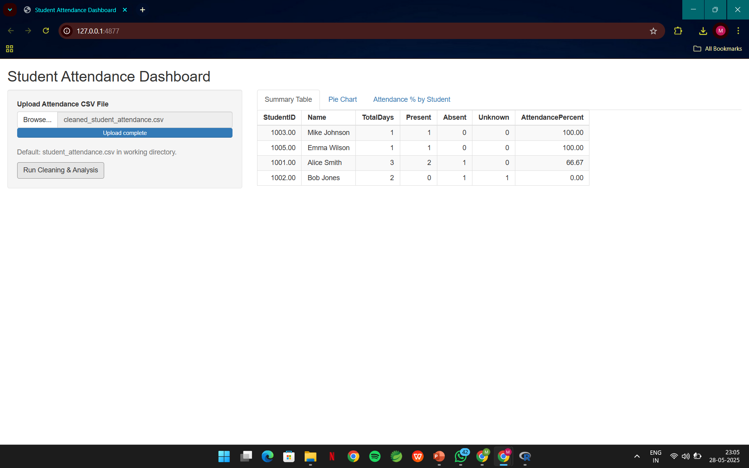

Fig. B. Data Cleaning Strategies

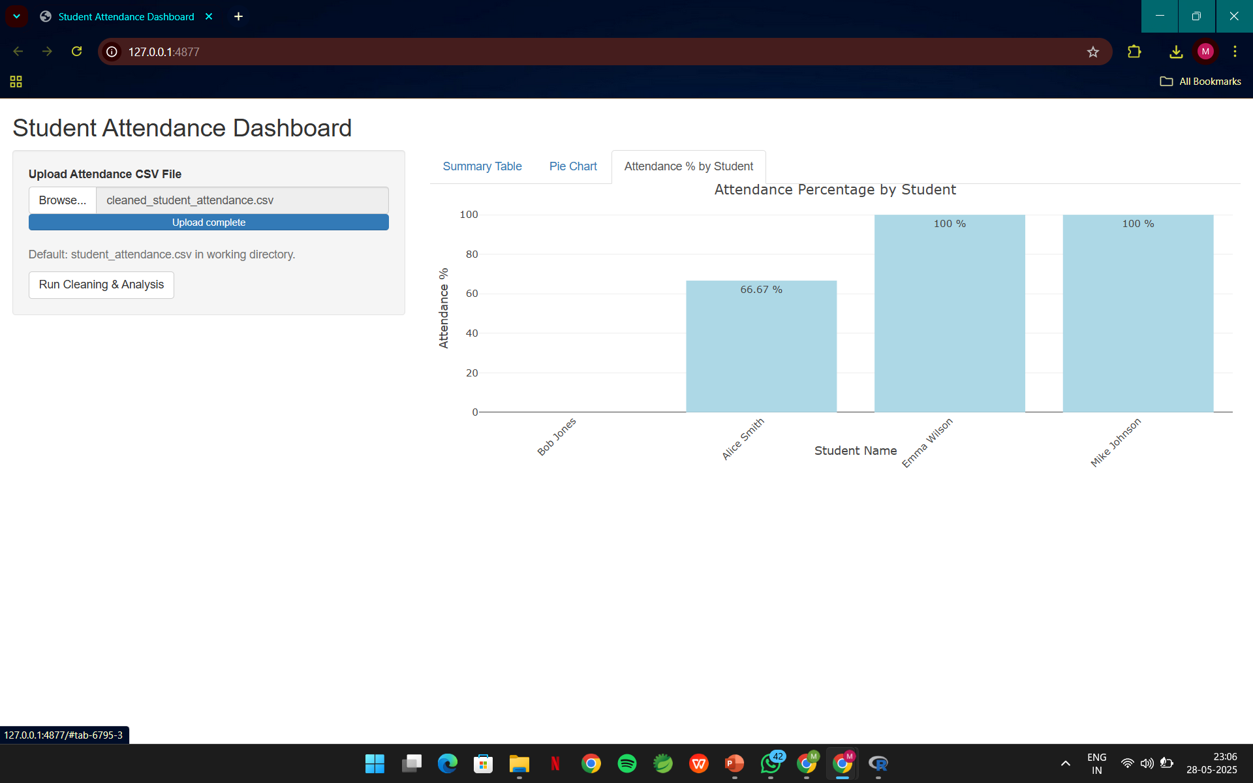
Fig. B. Analytical Methods and Summarization
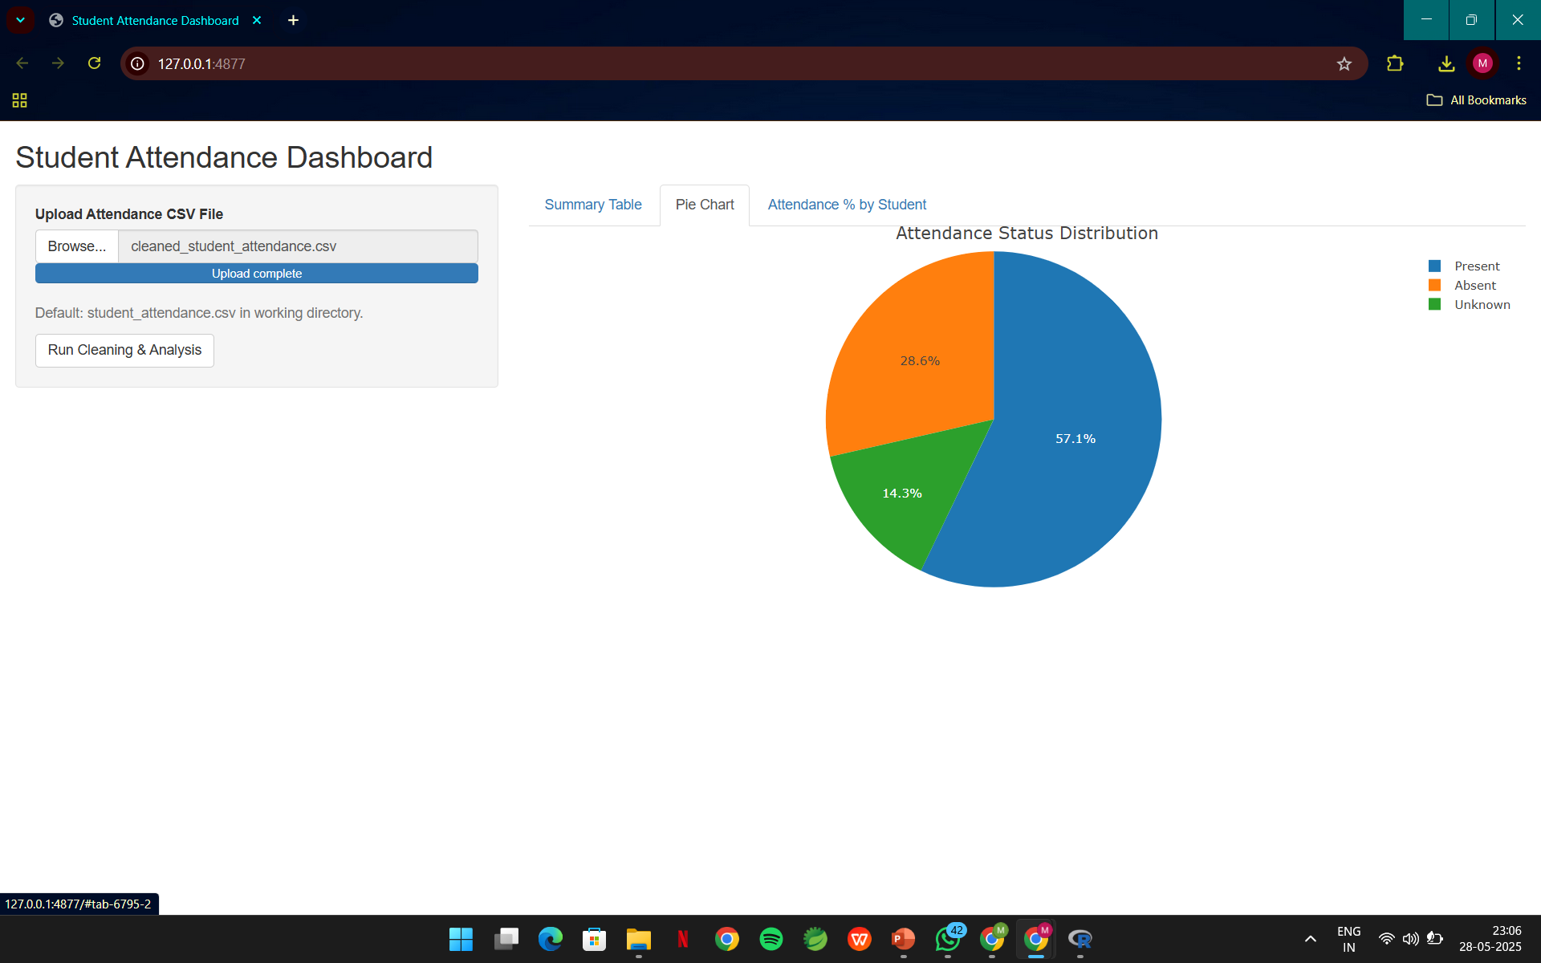
Fig. B. Visualization Techniques

REFERENCES

- R Official Documentation - https://cran.r-project.org/
- ggplot2 - https://ggplot2.tidyverse.org/
- dplyr and tidyr - https://dplyr.tidyverse.org/ and https://tidyr.tidyverse.org/
- kableExtra - https://haozhu233.github.io/kableExtra/
- Hypothesis Testing in R - https://www.rdocumentation.org/
- R for Data Science - https://r4ds.hadley.nz/

